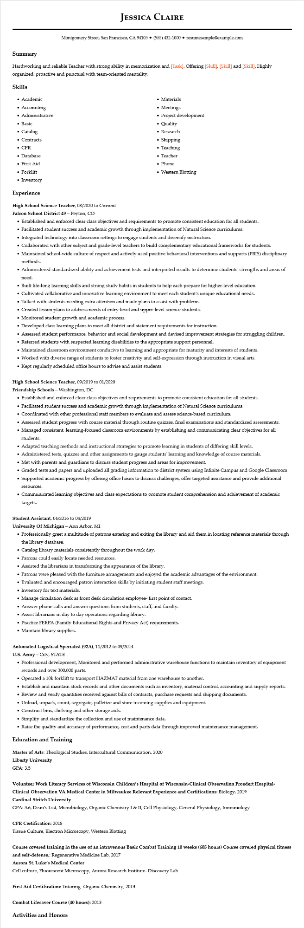
JESSICA CLAIRE
Montgomery Street, San Francisco, CA 94105⚫ (555) 432-1000⚫ resumesample@example.com
Summary
Hardworking and reliable Teacher with strong ability in memorization and [Task]. Offering [Skill], [Skill] and [Skill]. Highly organized, proactive and punctual with team-oriented mentality.
Skills
• Academic
• Accounting
• Administrative
• Basic
• Catalog
• Contracts
• CPR
• Database
• First Aid
• Forklift
• Inventory
Experience
High School Science Teacher, 08/2020 to Current
Falcon School District 49 - Peyton, CO
• Materials
• Meetings
• Project development
• Quality
• Research
.
Shipping
• Teaching
• Teacher
• Phone
• Western Blotting
• Established and enforced clear class objectives and requirements to promote consistent education for all students.
• Facilitated student success and academic growth through implementation of Natural Science curriculums.
• Integrated technology into classroom settings to engage students and diversify instruction.
• Collaborated with other subject and grade-level teachers to build complementary educational frameworks for students.
• Maintained school-wide culture of respect and actively used positive behavioral interventions and supports (PBIS) disciplinary methods.
• Administered standardized ability and achievement tests and interpreted results to determine students' strengths and areas of
need.
• Built life-long learning skills and strong study habits in students to help each prepare for higher-level education.
• Cultivated collaborative and innovative learning environment to meet each student's unique educational needs.
• Talked with students needing extra attention and made plans to assist with problems.
• Created lesson plans to address needs of entry-level and upper-level science students.
• Monitored student growth and academic process.
•
Developed class learning plans to meet all district and statement requirements for instruction.
• Assessed student performance, behavior and social development and devised improvement strategies for struggling children.
• Referred students with suspected learning disabilities to the appropriate support personnel.
• Maintained classroom environment conducive to learning and appropriate for maturity and interests of students.
• Worked with diverse range of students to foster creativity and self-expression through instruction in visual arts.
• Kept regularly scheduled office hours to advise and assist students.
High School Science Teacher, 09/2019 to 01/2020
Friendship Schools - Washington, DC
• Established and enforced clear class objectives and requirements to promote consistent education for all students.
• Facilitated student success and academic growth through implementation of Natural Science curriculums.
• Coordinated with other professional staff members to evaluate and assess science-based curriculum.
• Assessed student progress with course material through routine quizzes, final examinations and standardized assessments.
• Managed consistent, learning-focused classroom environments by establishing and communicating clear objectives for all students.
• Adapted teaching methods and instructional strategies to promote learning in students of differing skill levels.
• Administered tests, quizzes and other assignments to gauge students' learning and knowledge of course materials.
• Met with parents and guardians to discuss student progress and areas for improvement.
• Graded tests and papers and uploaded all grading information to district system using Infinite Campus and Google Classroom
• Supported academic progress by offering office hours to discuss challenges, offer targeted assistance and provide additional
resources.
• Communicated learning objectives and class expectations to promote student comprehension and achievement of academic targets.
Student Assistant, 04/2016 to 04/2019
University of Michigan - Ann Arbor, MI
• Professionally greet a multitude of patrons entering and exiting the library and aid them in locating reference materials through the library database.
• Catalog library materials consistently throughout the work day.
• Patrons could easily locate needed resources.
• Assisted the librarians in transforming the appearance of the library.
• Patrons were pleased with the furniture arrangements and enjoyed the academic advantages of the environment.
• Evaluated and encouraged patron interaction skills by initiating student staff meetings.
• Inventory for text materials.
• Manage circulation desk as front desk circulation employee- first point of contact.
• Answer phone calls and answer questions from students, staff, and faculty.
• Assist librarians in day to day operations regarding library.
• Practice FERPA (Family Educational Rights and Privacy Act) requirements.
• Maintain library supplies.
Automated Logistical Specialist (92A), 11/2012 to 09/2014
U.S. Army - City, STATE
• Professional development, Monitored and performed administrative warehouse functions to maintain inventory of equipment records and over 300,000 parts.
• Operated a 10k forklift to transport HAZMAT material from one warehouse to another.
• Establish and maintain stock records and other documents such as inventory, material control, accounting and supply reports.
• Review and verify quantities received against bills of contracts, purchase requests and shipping documents.
• Unload, unpack, count, segregate, palletize and store incoming supplies and equipment.
• Construct bins, shelving and other storage aids.
• Simplify and standardize the collection and use of maintenance data.
• Raise the quality and accuracy of performance, cost and parts data through improved maintenance management.
Education and Training
Master of Arts: Theological Studies, Intercultural Communication, 2020
Liberty University
GPA: 3.5
Volunteer Work Literacy Services of Wisconsin Children's Hospital of Wisconsin-Clinical Observation Froedert Hospital- Clinical Observation VA Medical Center in Milwaukee Relevant Experience and Certifications: Biology, 2019
Cardinal Stritch University
GPA: 3.6, Dean's List, Microbiology, Organic Chemistry I & II, Cell Physiology, General Physiology, Immunology
CPR Certification: 2018
Tissue Culture, Electron Microscopy, Western Blotting
Course covered training in the use of an intravenous Basic Combat Training 10 weeks (605 hours) Course covered physical fitness and self-defense.: Regenerative Medicine Lab, 2017
Aurora St. Luke's Medical Center
Cell culture, Fluorescent Microscopy, Aurora Research Institute- Discovery Lab
First Aid Certification: Tutoring- Organic Chemistry, 2013
Combat Lifesaver Course (40 hours): 2013
Activities and Honors

